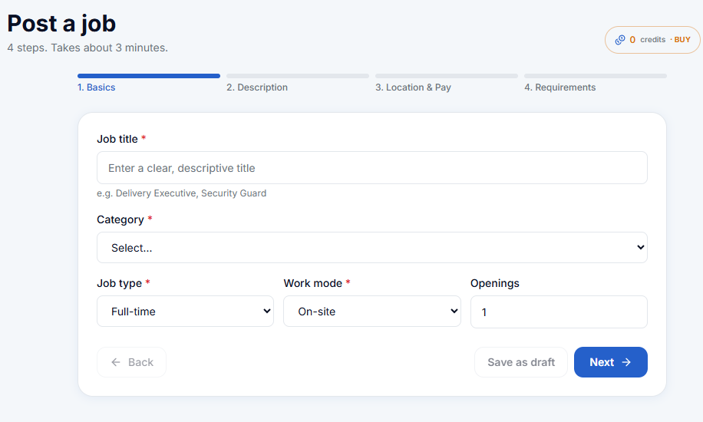
- Auto select category above & Ask for industry as well and add a gender selection:

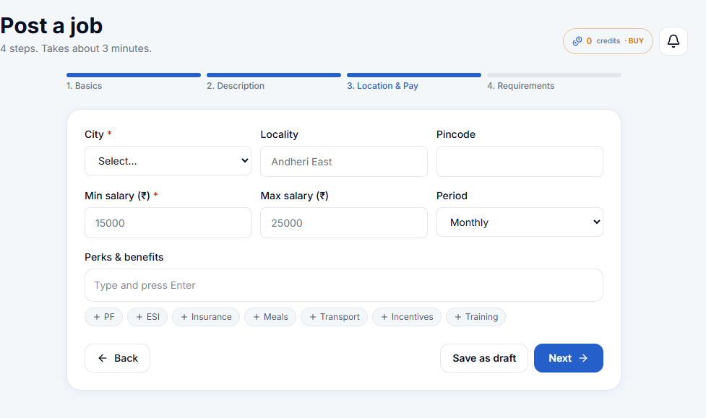

This will be page 2:
- Only ask for a monthly salary and auto calculate yearly CTC.
- Ask for Fixed Only & Fixed + Incentives as referred below:
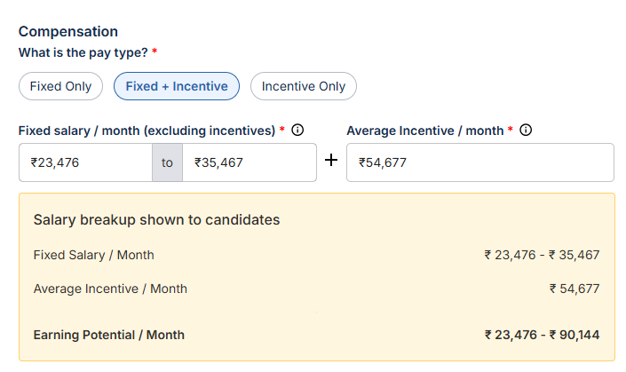
Add this too: 

If selected In-person(than page will open these options):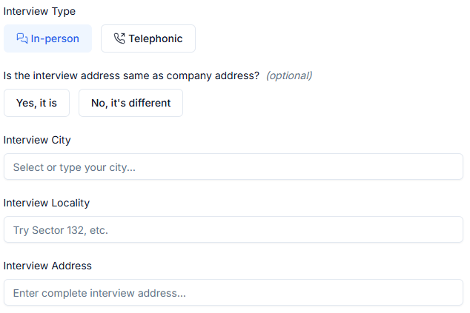

- Give a manual option to add perk as refer below: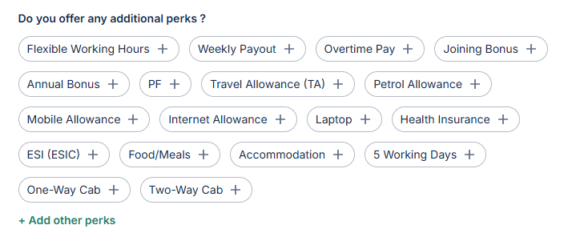
- Add this below perk: 
- Required upgrades in Page 4 which as shared below (will be placed as page 3) also:


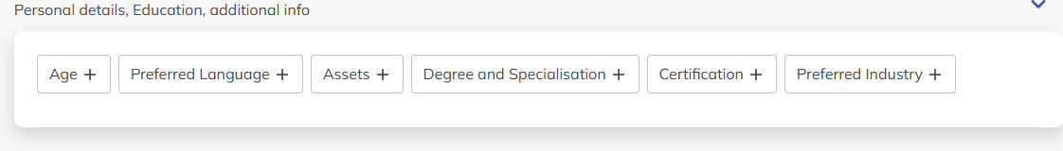

Now Page 2 (Description) will become page 4 as we have the entire required details from client of the role and now we will ask them to use template which is totally personalised according to the details client mentioned: